Assignment 5

Gaurav Sangappa – PES1201700282

Ananya Nair – PES1201700146

Abhilash Balaji – PES1201700041

Pranav Kelkar – PES1201700174

Problem statement:

On a chosen dataset, perform the time series model functions by calculating the moving average, single and double exponential smoothing.

Moving Averages

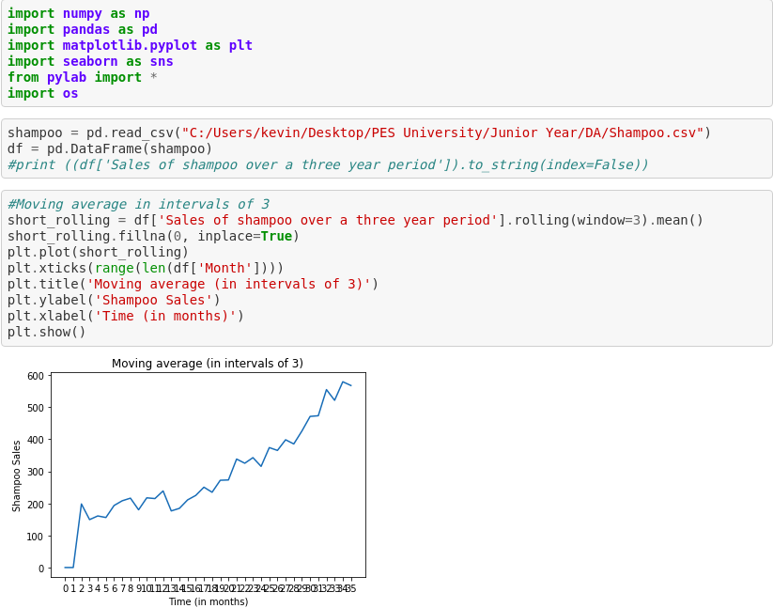

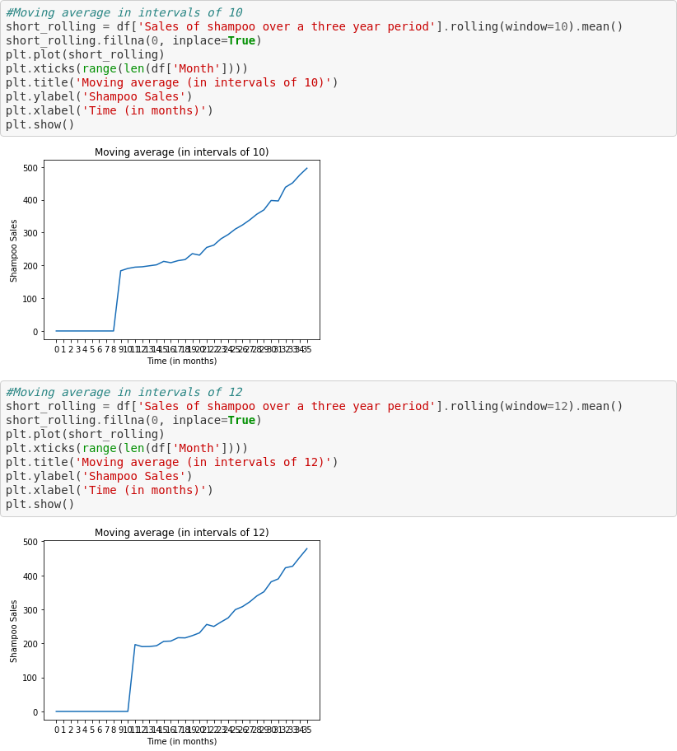

Single Exponential Smoothing

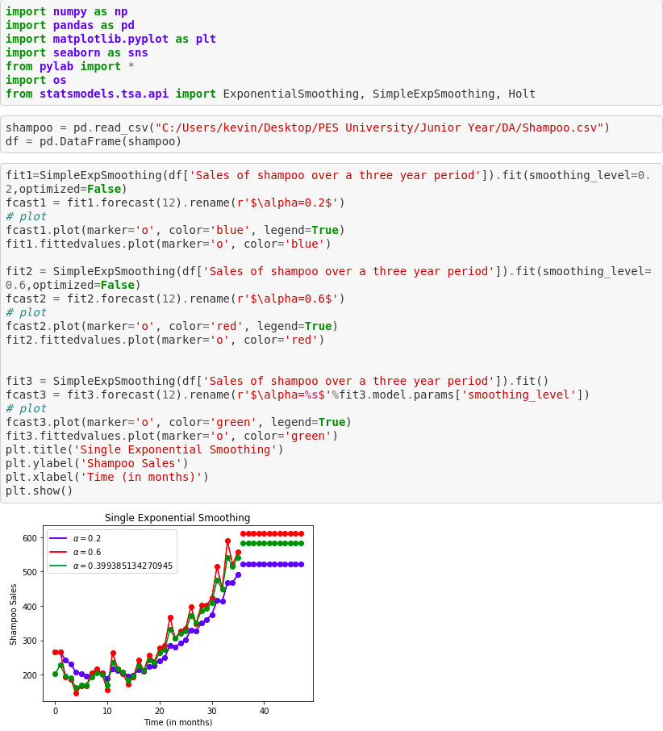

Double Exponential Smoothing

